Aplicación 2.10: Desarrollo humano en el mundo (Human Development Report 2019 [datos de 2018])

J. Ramajo

2020

library(readr)  
HDI_2018 <- read_delim("HDI_2018.csv", ";", escape_double = FALSE, trim_ws = TRUE)

## Parsed with column specification:  
## cols(  
## .default = col_double(),  
## Country = col_character()  
## )

## See spec(...) for full column specifications.

# Reescalamiento de variables  
HDI_2018$HDI <- 100*(HDI_2018$HDI) # (0-100 scores)  
HDI_2018$GNIpc <- (HDI_2018$GNIpc)/1000 # ( miles $ 2011 PPP)  
head(HDI_2018, n=10)

## # A tibble: 10 x 22  
## HDI_group Country HDI LifExp Educ GNIpc Pop PopUrbRat PopL5 PopB1564  
## <dbl> <chr> <dbl> <dbl> <dbl> <dbl> <dbl> <dbl> <dbl> <dbl>  
## 1 4 Norway 95.4 82.3 12.6 68.1 5.34 82.2 0.301 3.49   
## 2 4 Switze… 94.6 83.6 13.4 59.4 8.53 73.8 0.444 5.67   
## 3 4 Ireland 94.2 82.1 12.5 55.7 4.82 63.2 0.329 3.12   
## 4 4 Germany 93.9 81.2 14.1 46.9 83.1 77.3 3.87 54.0   
## 5 4 Hong K… 93.9 84.7 12.0 60.2 7.37 100 0.320 5.25   
## 6 4 Austra… 93.8 83.3 12.7 44.1 24.9 86 1.63 16.2   
## 7 4 Iceland 93.8 82.9 12.5 47.6 0.337 93.8 0.021 0.220  
## 8 4 Sweden 93.7 82.7 12.4 48.0 9.97 87.4 0.591 6.21   
## 9 4 Singap… 93.5 83.5 11.5 83.8 5.76 100 0.236 4.39   
## 10 4 Nether… 93.4 82.1 12.2 50.0 17.1 91.5 0.873 11.0   
## # … with 12 more variables: PopG65 <dbl>, DepRatB014 <dbl>, DepRatG65 <dbl>,  
## # FertRat <dbl>, EmpRat <dbl>, LFPRat <dbl>, EmpAgrRat <dbl>,  
## # EmpServRat <dbl>, UnempRat <dbl>, UnempRatB1524 <dbl>, NINIsRatB1524 <dbl>,  
## # HiSkLoSkEmpRat <dbl>

dim(HDI_2018)

## [1] 189 22

summary(HDI_2018)

## HDI_group Country HDI LifExp   
## Min. :1.000 Length:189 Min. :37.66 Min. :52.80   
## 1st Qu.:2.000 Class :character 1st Qu.:59.57 1st Qu.:67.34   
## Median :3.000 Mode :character Median :72.78 Median :73.86   
## Mean :2.751 Mean :71.34 Mean :72.50   
## 3rd Qu.:4.000 3rd Qu.:83.01 3rd Qu.:77.77   
## Max. :4.000 Max. :95.37 Max. :84.69   
##   
## Educ GNIpc Pop PopUrbRat   
## Min. : 1.586 Min. : 0.6597 Min. : 0.0179 Min. : 13.00   
## 1st Qu.: 6.348 1st Qu.: 3.9616 1st Qu.: 2.1193 1st Qu.: 40.10   
## Median : 9.018 Median : 11.6109 Median : 8.8028 Median : 58.50   
## Mean : 8.613 Mean : 18.4422 Mean : 39.9910 Mean : 58.34   
## 3rd Qu.:11.288 3rd Qu.: 26.7701 3rd Qu.: 28.8871 3rd Qu.: 77.60   
## Max. :14.132 Max. :110.4887 Max. :1427.6478 Max. :100.00   
##   
## PopL5 PopB1564 PopG65 DepRatB014   
## Min. : 0.0074 Min. : 0.0605 Min. : 0.0045 Min. : 15.91   
## 1st Qu.: 0.2235 1st Qu.: 1.8426 1st Qu.: 0.1430 1st Qu.: 26.52   
## Median : 0.7274 Median : 5.9306 Median : 0.5520 Median : 41.22   
## Mean : 3.6627 Mean : 26.9888 Mean : 3.6645 Mean : 45.77   
## 3rd Qu.: 2.9383 3rd Qu.: 17.8019 3rd Qu.: 2.0377 3rd Qu.: 62.84   
## Max. :116.3794 Max. :1016.5154 Max. :155.9118 Max. :105.41   
## NA's :6 NA's :6 NA's :6 NA's :6   
## DepRatG65 FertRat EmpRat LFPRat   
## Min. : 1.287 Min. :1.110 Min. :28.80 Min. :31.40   
## 1st Qu.: 5.965 1st Qu.:1.735 1st Qu.:51.62 1st Qu.:56.10   
## Median : 9.256 Median :2.283 Median :58.85 Median :62.25   
## Mean :13.401 Mean :2.728 Mean :58.08 Mean :62.33   
## 3rd Qu.:20.160 3rd Qu.:3.616 3rd Qu.:64.20 3rd Qu.:68.30   
## Max. :46.171 Max. :6.950 Max. :86.80 Max. :86.90   
## NA's :6 NA's :6 NA's :11 NA's :11   
## EmpAgrRat EmpServRat UnempRat UnempRatB1524   
## Min. : 0.100 Min. : 6.00 Min. : 0.100 Min. : 0.40   
## 1st Qu.: 5.575 1st Qu.:41.90 1st Qu.: 3.400 1st Qu.: 7.80   
## Median :18.500 Median :56.70 Median : 5.500 Median :12.40   
## Mean :26.001 Mean :54.46 Mean : 7.188 Mean :15.92   
## 3rd Qu.:41.100 3rd Qu.:69.95 3rd Qu.: 9.375 3rd Qu.:21.23   
## Max. :92.000 Max. :88.10 Max. :30.200 Max. :52.90   
## NA's :11 NA's :11 NA's :11 NA's :11   
## NINIsRatB1524 HiSkLoSkEmpRat   
## Min. : 0.06 Min. : 0.0797   
## 1st Qu.: 9.85 1st Qu.: 0.8251   
## Median :17.01 Median : 1.7288   
## Mean :18.83 Mean : 2.9244   
## 3rd Qu.:26.98 3rd Qu.: 3.7212   
## Max. :52.05 Max. :46.8367   
## NA's :62 NA's :35

# RELACIÓN ENTRE EL HDI Y SUS DIMENSIONES BÁSICAS  
library(car)

## Loading required package: carData

library(sfsmisc)  
#  
scatterplotMatrix(~HDI + GNIpc + LifExp + Educ, data=HDI_2018,   
 var.labels=c("HDI", "GNIpc", "LifExp", "Educ"),  
 smooth=list(smoother=loessLine, var=FALSE, lwd.smooth=3),   
 col="black")

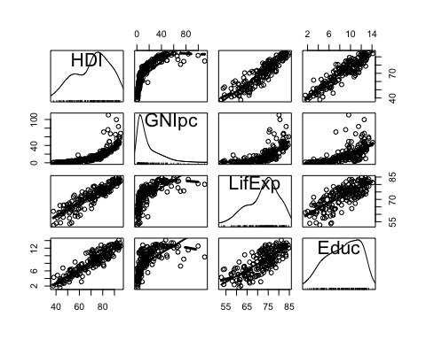

#  
scatterplot(HDI ~ GNIpc, data=HDI_2018, smooth=list(smoother=loessLine, var=FALSE,   
 lwd.smooth=3), col="black",  
 regLine=list(lwd=3),  
 xlab="GNIpc",   
 ylab="HDI")

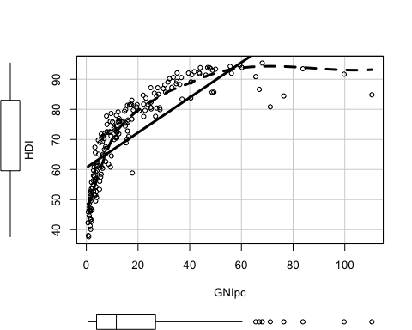

#  
scatterplot(HDI ~ LifExp, data=HDI_2018, smooth=list(smoother=loessLine, var=FALSE,   
 lwd.smooth=3), col="black",  
 regLine=list(lwd=3),  
 xlab="LifExp",   
 ylab="HDI")

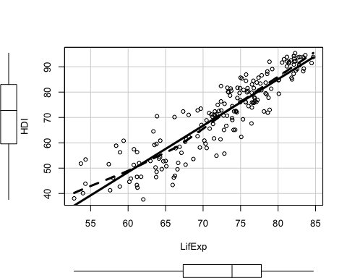

#  
scatterplot(HDI ~ Educ, data=HDI_2018, smooth=list(smoother=loessLine, var=FALSE,   
 lwd.smooth=3), col="black",  
 regLine=list(lwd=3),  
 xlab="Educ",   
 ylab="HDI")

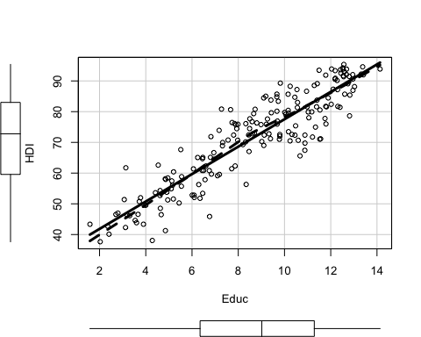

# Regresión por MCO  
MRL <- lm(HDI ~ GNIpc + LifExp + Educ, data=HDI_2018)  
S(MRL)

## Call: lm(formula = HDI ~ GNIpc + LifExp + Educ, data = HDI_2018)  
##   
## Coefficients:  
## Estimate Std. Error t value Pr(>|t|)   
## (Intercept) -12.55031 3.12104 -4.021 8.43e-05 ***  
## GNIpc 0.14556 0.01612 9.031 2.23e-16 ***  
## LifExp 0.84508 0.05205 16.237 < 2e-16 ***  
## Educ 2.31570 0.11986 19.320 < 2e-16 ***  
## ---  
## Signif. codes: 0 '***' 0.001 '**' 0.01 '*' 0.05 '.' 0.1 ' ' 1  
##   
## Residual standard deviation: 3.164 on 185 degrees of freedom  
## Multiple R-squared: 0.9567  
## F-statistic: 1362 on 3 and 185 DF, p-value: < 2.2e-16   
## AIC BIC   
## 977.68 993.89

cis <- confint(MRL)  
cis

## 2.5 % 97.5 %  
## (Intercept) -18.7077128 -6.3928973  
## GNIpc 0.1137623 0.1773614  
## LifExp 0.7423941 0.9477577  
## Educ 2.0792385 2.5521683

b <- coef(MRL)  
b

## (Intercept) GNIpc LifExp Educ   
## -12.5503050 0.1455619 0.8450759 2.3157034

#  
confidenceEllipse(MRL, L=c("GNIpc", "LifExp"), segments=500, levels=c(0.95), col="black", fill=TRUE, axes=TRUE, ann=TRUE, grid=TRUE)

## Warning in plot.xy(xy.coords(x, y), type = type, ...): "axes" is not a graphical  
## parameter

box()  
usr <- par("usr")  
abline(v=cis[2, ], h=cis[3, ], lty=2)  
lines(x=c(usr[1], b[2]), y=c(b[3], b[3]))  
lines(x=c(b[2], b[2]), y=c(usr[3], b[3]))  
par <- par("xpd"=TRUE)  
p.arrows(cis[2, 1], usr[3], cis[2, 2], usr[3], lwd=3, fill="black",   
 xpd=TRUE, size=1.25)  
p.arrows(cis[2, 2], usr[3], cis[2, 1], usr[3], lwd=3, fill="black",   
 xpd=TRUE, size=1.25)  
p.arrows(usr[1], cis[3, 1], usr[1], cis[3, 2], lwd=3, fill="black",   
 xpd=TRUE, size=1.25)  
p.arrows(usr[1], cis[3, 2], usr[1], cis[3, 1], lwd=3, fill="black",   
 xpd=TRUE, size=1.25)

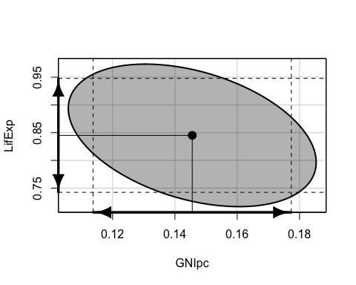

par(par)  
#  
confidenceEllipse(MRL, L=c("GNIpc", "Educ"), segments=500, levels=c(0.95), col="black", fill=TRUE, axes=TRUE, ann=TRUE, grid=TRUE)

## Warning in plot.xy(xy.coords(x, y), type = type, ...): "axes" is not a graphical  
## parameter

box()  
usr <- par("usr")  
abline(v=cis[2, ], h=cis[4, ], lty=2)  
lines(x=c(usr[1], b[2]), y=c(b[4], b[4]))  
lines(x=c(b[2], b[2]), y=c(usr[3], b[4]))  
par <- par("xpd"=TRUE)  
p.arrows(cis[2, 1], usr[3], cis[2, 2], usr[3], lwd=3, fill="black",   
 xpd=TRUE, size=1.25)  
p.arrows(cis[2, 2], usr[3], cis[2, 1], usr[3], lwd=3, fill="black",   
 xpd=TRUE, size=1.25)  
p.arrows(usr[1], cis[4, 1], usr[1], cis[4, 2], lwd=3, fill="black",   
 xpd=TRUE, size=1.25)  
p.arrows(usr[1], cis[4, 2], usr[1], cis[4, 1], lwd=3, fill="black",   
 xpd=TRUE, size=1.25)

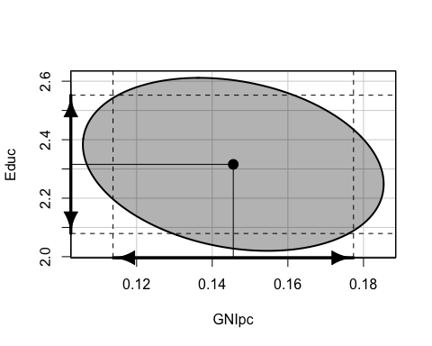

par(par)

# ANÁLISIS Y TRANSFORMACIÓN DE DATOS  
library(car)  
library(RcmdrMisc)

## Loading required package: sandwich

# Análisis gráficos del índice de desarrollo humano  
par(mfrow=c(2, 2))  
Hist(HDI_2018$HDI, xlab="HDI", ylab="Frecuencia", col="gray", main="(a)")  
Boxplot(~HDI, data=HDI_2018, main="(b)", ylab="HDI")  
densityPlot(~HDI, data=HDI_2018, xlab="HDI", ylab = "Densidad", main="(c)")  
qqPlot(~HDI, data=HDI_2018, ylab="HDI", xlab="Cuantiles N(0,1)", main="(d)")

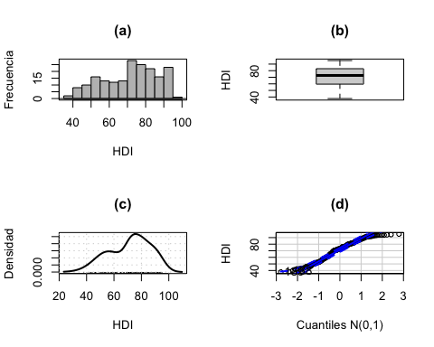

## [1] 189 188

par(par)  
# Heterogeneidad (por categorías de desarrollo)  
Boxplot(HDI ~ HDI_group, data=HDI_2018, id=list(location="Country"),   
 ylab="HDI", xlab="Categoría de desarrollo (de 1 a 4)")  
#  
spreadLevelPlot(HDI ~ HDI_group, data=HDI_2018, main="", xlab="Mediana",  
 ylab="Rango intercuartilítico", col.lines="black")

## LowerHinge Median UpperHinge Hinge-Spread  
## 1 44.225 49.040 52.025 7.80  
## 2 58.840 61.420 65.110 6.27  
## 3 72.020 74.475 76.740 4.72  
## 4 83.380 87.250 91.990 8.61  
##   
## Suggested power transformation: 1.067785

# Transformación de la variable HDI  
# La transformación de Box-Cox  
par(mfrow=c(1, 1))

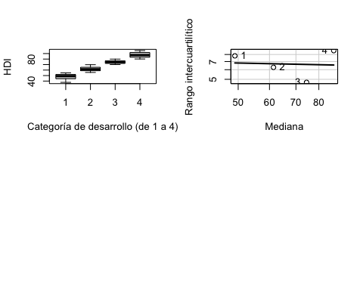

#  
n <- 500  
x <- seq(0.1, 3, length=n)  
x1 <- bcPower(x, 1)  
x0.5 <- bcPower(x, 0.5)  
x0 <- bcPower(x, 0)  
xm0.5 <- bcPower(x, -0.5)  
xm1 <- bcPower(x, -1)  
x2 <- bcPower(x, 2)  
x3 <- bcPower(x, 3)  
xlim <- range(c(x1, x0.5, x0, xm0.5, xm1, x2, x3))  
#  
plot(range(x)+ c(-0.6, 0.5), c(-5, 10), type="n", xlab="", ylab="", las=1)  
usr <- par("usr")  
text(usr[2], usr[3] - 1, label="x", xpd=TRUE)  
text(usr[1] - 0.2, usr[4] + 0.75, label=expression(t[BC](x, lambda)), xpd=TRUE)  
lines(x, x1, lwd=2)  
text(x[n]+0.0625, x1[n], labels=expression(lambda == 1), adj=c(0, 0.2))  
lines(x, x2, lwd=2)  
text(x[n]+0.0625, x2[n], labels=expression(lambda == 2), adj=c(0, 0.2))  
lines(x, x3, lwd=2)  
text(x[n]+0.0625, x3[n], labels=expression(lambda == 3), adj=c(0, 0.2))  
lines(x, x0.5, lwd=2)  
text(x[1]-0.025, x0.5[1], labels=expression(lambda == 0.5), adj=c(1, 0.3))  
lines(x, x0, lwd=2)  
text(x[1]-0.025, x0[1], labels=expression(lambda == 0), adj=c(1, 0.3))  
lines(x, xm0.5, lwd=2)  
text(x[1]-0.025, xm0.5[1], labels=expression(lambda == -0.5), adj=c(1, 0.3))  
lines(x=c(1, 1), y=c(usr[3], 0), lty=2)  
lines(x=c(usr[1], 1), y=c(0, 0), lty=2)

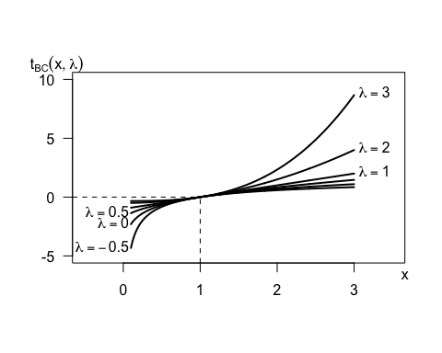

par(par)  
# HDI: boxplots de las variables transformadas   
symbox(~HDI, data=HDI_2018, xlab=expression("Potencias,"~lambda), ylab="",   
 powers = c(-1, -0.5, 0, 0.33, 0.5, 1))  
mtext(2, 1, text=expression(t[BC]("HDI",~lambda)))

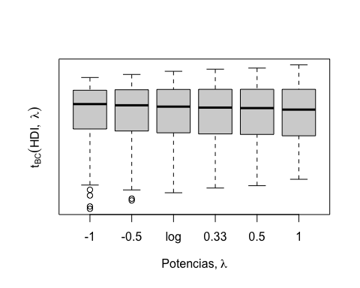

# Estimación del parámetro lambda para HDI  
S(tBC <- powerTransform(HDI ~ 1, data=HDI_2018))

## bcPower Transformation to Normality   
## Est Power Rounded Pwr Wald Lwr Bnd Wald Upr Bnd  
## Y1 1.6457 1 0.9679 2.3235  
##   
## Likelihood ratio test that transformation parameter is equal to 0  
## (log transformation)  
## LRT df pval  
## LR test, lambda = (0) 24.29013 1 8.2863e-07  
##   
## Likelihood ratio test that no transformation is needed  
## LRT df pval  
## LR test, lambda = (1) 3.590143 1 0.058123

tBC$lambda # estimated lambda

## Y1   
## 1.645699

sqrt(tBC$invHess) # SE

## [,1]  
## [1,] 0.3458126

# Estimación del parámetro lambda para todas las variables del modelo  
S(tBC_all <- powerTransform(cbind(HDI, GNIpc, LifExp, Educ) ~ 1, data=HDI_2018))

## bcPower Transformations to Multinormality   
## Est Power Rounded Pwr Wald Lwr Bnd Wald Upr Bnd  
## HDI 1.3446 1.34 1.0966 1.5926  
## GNIpc -0.0072 0.00 -0.0676 0.0532  
## LifExp 3.4492 3.45 2.6273 4.2710  
## Educ 1.0524 1.00 0.8310 1.2737  
##   
## Likelihood ratio test that transformation parameters are equal to 0  
## (all log transformations)  
## LRT df pval  
## LR test, lambda = (0 0 0 0) 216.253 4 < 2.22e-16  
##   
## Likelihood ratio test that no transformations are needed  
## LRT df pval  
## LR test, lambda = (1 1 1 1) 615.6299 4 < 2.22e-16

#  
scatterplotMatrix( ~basicPower(HDI, 1.3) + log(GNIpc) + basicPower(LifExp, 3.5) + Educ, data=HDI_2018,  
 var.labels=c(expression("tBC(HDI)"),   
 expression("tBC(GNIpc)"),   
 expression("tBC(LifExp)"),   
 expression("tBC(Educ)")),  
 smooth=list(smoother=loessLine, var=FALSE, lwd.smooth=3),   
 col="black")

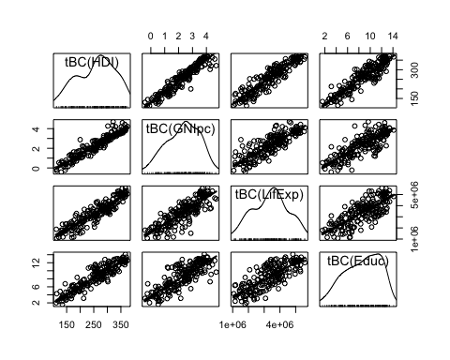

# DATOS ATÍPICOS  
library(MASS)  
library(car)  
S(MRL <- lm(HDI ~ GNIpc + LifExp + Educ, data=HDI_2018))

## Call: lm(formula = HDI ~ GNIpc + LifExp + Educ, data = HDI_2018)  
##   
## Coefficients:  
## Estimate Std. Error t value Pr(>|t|)   
## (Intercept) -12.55031 3.12104 -4.021 8.43e-05 ***  
## GNIpc 0.14556 0.01612 9.031 2.23e-16 ***  
## LifExp 0.84508 0.05205 16.237 < 2e-16 ***  
## Educ 2.31570 0.11986 19.320 < 2e-16 ***  
## ---  
## Signif. codes: 0 '***' 0.001 '**' 0.01 '*' 0.05 '.' 0.1 ' ' 1  
##   
## Residual standard deviation: 3.164 on 185 degrees of freedom  
## Multiple R-squared: 0.9567  
## F-statistic: 1362 on 3 and 185 DF, p-value: < 2.2e-16   
## AIC BIC   
## 977.68 993.89

# Medidas de diagnosis de valores atípicos  
max(hatvalues(MRL))

## [1] 0.1834951

which.max(hatvalues(MRL))

## 41   
## 41

outlierTest(MRL)

## No Studentized residuals with Bonferroni p < 0.05  
## Largest |rstudent|:  
## rstudent unadjusted p-value Bonferroni p  
## 41 -3.140262 0.001967 0.37176

max(cooks.distance(MRL))

## [1] 0.5287108

which.max(cooks.distance(MRL))

## 41   
## 41

# Una vez encontrado el atípico(s)  
dffits(MRL)[41]

## 41   
## -1.488671

which.max(abs(dffits(MRL)))

## 41   
## 41

round(dfbeta(MRL)[41, ], 5)

## (Intercept) GNIpc LifExp Educ   
## -1.11960 -0.02257 0.01350 0.05806

round(dfbetas(MRL)[41, ], 5)

## (Intercept) GNIpc LifExp Educ   
## -0.36722 -1.43370 0.26561 0.49586

# Graficos av (added-variable)  
avPlots(MRL, id=FALSE, col.lines="black", main="")

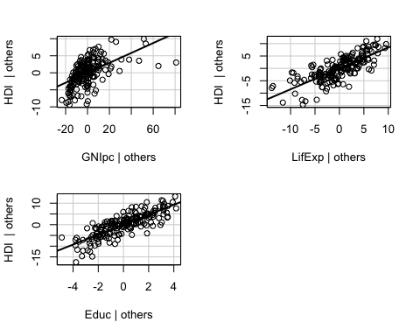

#  
par <- par(mfrow=c(1, 3))  
avPlot(MRL,"GNIpc", main="(a)", id=list(method="mahal", n=3),   
 xlab="GNIpc | Resto de Xs", ylab="HDI | Resto de Xs",  
 col.lines="black")  
avPlot(MRL,"LifExp", main="(b)", id=list(method="mahal", n=3),   
 xlab="LifExp | Resto de Xs", ylab="HDI | Resto de Xs",  
 col.lines="black")  
avPlot(MRL,"Educ", main="(c)", id=list(method="mahal", n=3),   
 xlab="Educ | Resto de Xs", ylab="HDI | Resto de Xs",  
 col.lines="black")

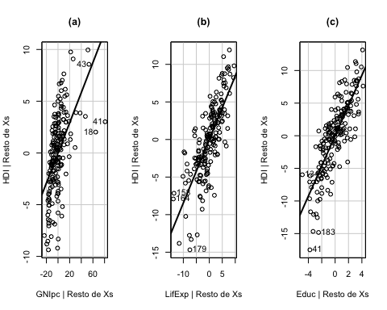

par(par)  
# Outlier & Leverages  
influencePlot(MRL, xlab="Hatvalues")

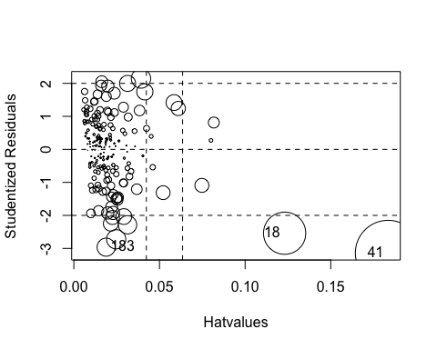

## StudRes Hat CookD  
## 18 -2.539514 0.12307635 0.21980972  
## 41 -3.140262 0.18349513 0.52871078  
## 183 -2.962500 0.01886544 0.04048675

# Nueva regresión eliminando los atípicos  
S(update(MRL, subset=-c(18, 41, 183)))

## Call: lm(formula = HDI ~ GNIpc + LifExp + Educ, data = HDI_2018, subset =  
## -c(18, 41, 183))  
##   
## Coefficients:  
## Estimate Std. Error t value Pr(>|t|)   
## (Intercept) -10.00576 2.95834 -3.382 0.00088 ***  
## GNIpc 0.18958 0.01775 10.679 < 2e-16 ***  
## LifExp 0.81437 0.04912 16.580 < 2e-16 ***  
## Educ 2.20438 0.11363 19.399 < 2e-16 ***  
## ---  
## Signif. codes: 0 '***' 0.001 '**' 0.01 '*' 0.05 '.' 0.1 ' ' 1  
##   
## Residual standard deviation: 2.945 on 182 degrees of freedom  
## Multiple R-squared: 0.9618  
## F-statistic: 1529 on 3 and 182 DF, p-value: < 2.2e-16   
## AIC BIC   
## 935.66 951.79

# NO NORMALIDAD Y HETEROSCEDASTICIDAD  
#  
# Análisis de la hipótesis de normalidad  
#  
MRL <- lm(HDI ~ GNIpc + LifExp + Educ, data=HDI_2018)  
# Gráfica de densidad de losresiduos estudentizados  
densityPlot(rstudent(MRL), adjust=0.75, n=1000, xlab="Studentized Residuals")

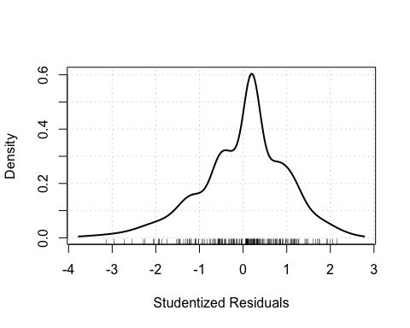

# Gráfica QQ de los residuos estudentizados  
qqPlot(MRL, reps=1000, id=FALSE, col.lines="black",   
 ylab="Ordered Studentized Residuals")

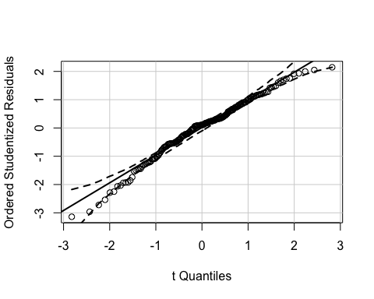

# Gráfico de cajas de los residuos estudentizados   
Boxplot(rstudent(MRL), id=FALSE, xlab="Boxplot", ylab="Studentized Residuals")

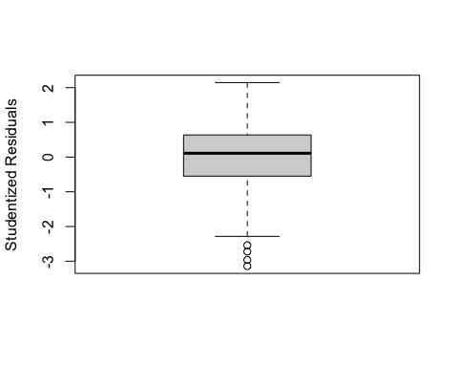

#  
# Análisis de la hipótesis de homoscedasticidad  
#  
# Gráfico de los residuos estudentizados vs valores ajustados   
scatterplot(fitted(MRL), rstudent(MRL), smooth=list(span=2/3,   
 lwd.smooth=3, lwd.spread=3), regLine=FALSE,  
 boxplots=FALSE, col=c("black", "black"), main="",  
 xlab="Fitted Values", ylab="Studentized Residuals")  
abline(0, 0)

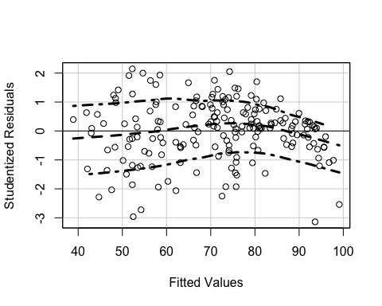

# Gráfico de amplitud (spread-level)  
spreadLevelPlot(MRL, main="", smooth=FALSE, col.lines="black")

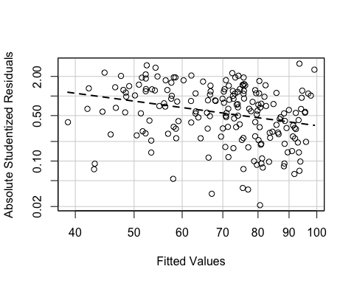

##   
## Suggested power transformation: 2.251125

# Contraste de Breusch-Pagan  
ncvTest(MRL)

## Non-constant Variance Score Test   
## Variance formula: ~ fitted.values   
## Chisquare = 9.579756, Df = 1, p = 0.0019673

ncvTest(MRL, var.formula= ~ GNIpc + LifExp + Educ)

## Non-constant Variance Score Test   
## Variance formula: ~ GNIpc + LifExp + Educ   
## Chisquare = 23.32466, Df = 3, p = 3.4555e-05

# Correcciones: errores estándar robustos y errores re-muestreados (bootstrapped)  
S(MRL, vcov.=hccm(MRL))

## Call: lm(formula = HDI ~ GNIpc + LifExp + Educ, data = HDI_2018)  
## Standard errors computed by hccm(MRL)   
##   
## Coefficients:  
## Estimate Std. Error t value Pr(>|t|)   
## (Intercept) -12.55031 3.97762 -3.155 0.00187 **   
## GNIpc 0.14556 0.02980 4.885 2.23e-06 ***  
## LifExp 0.84508 0.06428 13.147 < 2e-16 ***  
## Educ 2.31570 0.14231 16.272 < 2e-16 ***  
## ---  
## Signif. codes: 0 '***' 0.001 '**' 0.01 '*' 0.05 '.' 0.1 ' ' 1  
##   
## Residual standard deviation: 3.164 on 185 degrees of freedom  
## Multiple R-squared: 0.9567  
## F-statistic: 1225 on 3 and 185 DF, p-value: < 2.2e-16   
## AIC BIC   
## 977.68 993.89

boot.MRL <- Boot(MRL, R=1000)

## Loading required namespace: boot

S(MRL, vcov.=vcov(boot.MRL))

## Call: lm(formula = HDI ~ GNIpc + LifExp + Educ, data = HDI_2018)  
## Standard errors computed by vcov(boot.MRL)   
##   
## Coefficients:  
## Estimate Std. Error t value Pr(>|t|)   
## (Intercept) -12.55031 3.72003 -3.374 0.000903 ***  
## GNIpc 0.14556 0.02758 5.278 3.63e-07 ***  
## LifExp 0.84508 0.06004 14.076 < 2e-16 ***  
## Educ 2.31570 0.12959 17.870 < 2e-16 ***  
## ---  
## Signif. codes: 0 '***' 0.001 '**' 0.01 '*' 0.05 '.' 0.1 ' ' 1  
##   
## Residual standard deviation: 3.164 on 185 degrees of freedom  
## Multiple R-squared: 0.9567  
## F-statistic: 1367 on 3 and 185 DF, p-value: < 2.2e-16   
## AIC BIC   
## 977.68 993.89

# NO LINEALIDAD  
MRL <- lm(HDI ~ GNIpc + LifExp + Educ, data=HDI_2018)  
S(MRL)

## Call: lm(formula = HDI ~ GNIpc + LifExp + Educ, data = HDI_2018)  
##   
## Coefficients:  
## Estimate Std. Error t value Pr(>|t|)   
## (Intercept) -12.55031 3.12104 -4.021 8.43e-05 ***  
## GNIpc 0.14556 0.01612 9.031 2.23e-16 ***  
## LifExp 0.84508 0.05205 16.237 < 2e-16 ***  
## Educ 2.31570 0.11986 19.320 < 2e-16 ***  
## ---  
## Signif. codes: 0 '***' 0.001 '**' 0.01 '*' 0.05 '.' 0.1 ' ' 1  
##   
## Residual standard deviation: 3.164 on 185 degrees of freedom  
## Multiple R-squared: 0.9567  
## F-statistic: 1362 on 3 and 185 DF, p-value: < 2.2e-16   
## AIC BIC   
## 977.68 993.89

# Gráficos C+R (Component-plus-Residuals o residuos parciales) y CERES  
crPlots(MRL)

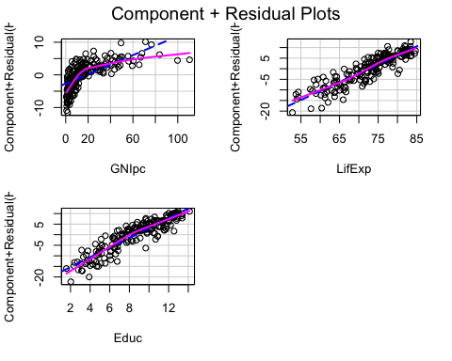

# Figuras individuales  
crPlot(MRL, "GNIpc", xlab="GNIpc", col.lines=c("black", "black"),   
 ylab="Component+Residual",   
 smooth=list(span=3/4), main="")

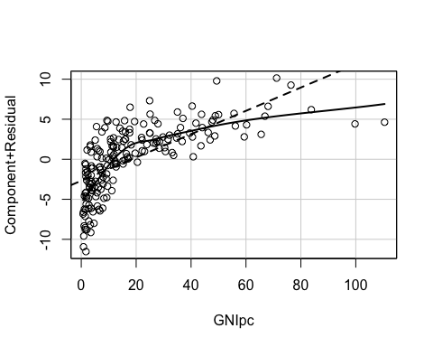

crPlot(MRL, "LifExp", xlab="LifExp",   
 col.lines=c("black", "black"), ylab="Component+Residual",   
 smooth=list(span=3/4), main="")

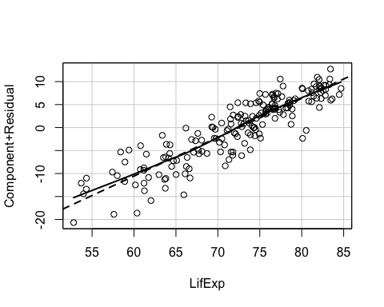

crPlot(MRL, "Educ", xlab="Educ",   
 col.lines=c("black", "black"), ylab="Component+Residual",   
 smooth=list(span=3/4), main="")

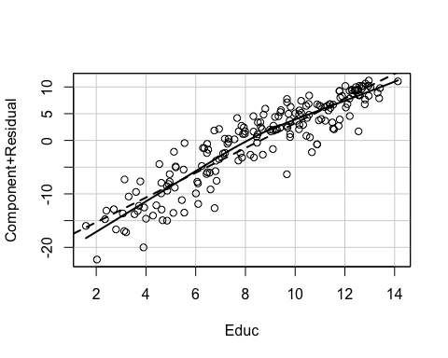

#  
ceresPlots(MRL)

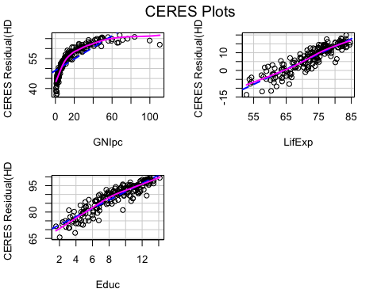

#  
# Modelo re-especificado: incluye un término cuadrático en la variable GNIpc  
MRL.2 <- update(MRL, . ~ poly(GNIpc, 2, raw=TRUE) + LifExp + Educ)  
S(MRL.2)

## Call: lm(formula = HDI ~ poly(GNIpc, 2, raw = TRUE) + LifExp + Educ, data =  
## HDI_2018)  
##   
## Coefficients:  
## Estimate Std. Error t value Pr(>|t|)   
## (Intercept) -3.105983 2.658889 -1.168 0.244   
## poly(GNIpc, 2, raw = TRUE)1 0.505837 0.037365 13.538 <2e-16 ***  
## poly(GNIpc, 2, raw = TRUE)2 -0.003965 0.000386 -10.272 <2e-16 ***  
## LifExp 0.708359 0.043682 16.216 <2e-16 ***  
## Educ 1.932979 0.102801 18.803 <2e-16 ***  
## ---  
## Signif. codes: 0 '***' 0.001 '**' 0.01 '*' 0.05 '.' 0.1 ' ' 1  
##   
## Residual standard deviation: 2.529 on 184 degrees of freedom  
## Multiple R-squared: 0.9725  
## F-statistic: 1625 on 4 and 184 DF, p-value: < 2.2e-16   
## AIC BIC   
## 894.01 913.46

#  
anova(MRL, MRL.2)

## Analysis of Variance Table  
##   
## Model 1: HDI ~ GNIpc + LifExp + Educ  
## Model 2: HDI ~ poly(GNIpc, 2, raw = TRUE) + LifExp + Educ  
## Res.Df RSS Df Sum of Sq F Pr(>F)   
## 1 185 1851.8   
## 2 184 1176.9 1 674.89 105.52 < 2.2e-16 ***  
## ---  
## Signif. codes: 0 '***' 0.001 '**' 0.01 '*' 0.05 '.' 0.1 ' ' 1

# Graficos C+R del modelo re-especificado  
crPlot(MRL.2, "poly(GNIpc, 2, raw = TRUE)",   
 xlab="GNIpc (cuadrático)",   
 col.lines=c("black", "black"), ylab="Component+Residual",   
 smooth=list(span=3/4), main="")

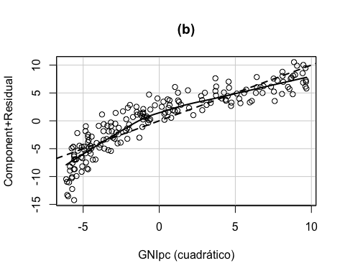

crPlot(MRL.2, "LifExp", xlab="LifExp",   
 col.lines=c("black", "black"), ylab="Component+Residual",   
 smooth=list(span=3/4), main="")

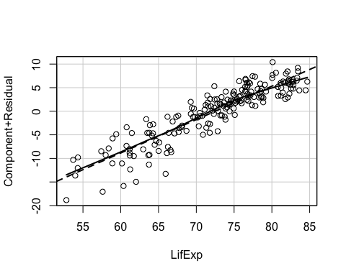

crPlot(MRL.2, "Educ", xlab="Educ",   
 col.lines=c("black", "black"), ylab="Component+Residual",   
 smooth=list(span=3/4), main="")

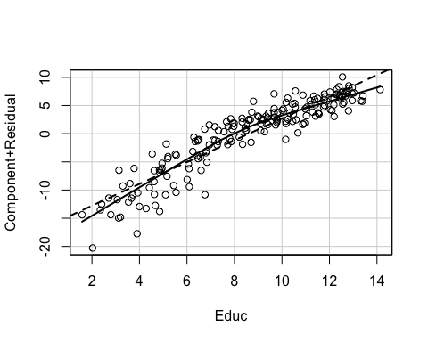

# Graficos C+R frente a las variables Xs sin transformar  
library(effects)

## Registered S3 methods overwritten by 'lme4':  
## method from  
## cooks.distance.influence.merMod car   
## influence.merMod car   
## dfbeta.influence.merMod car   
## dfbetas.influence.merMod car

## lattice theme set by effectsTheme()  
## See ?effectsTheme for details.

plot(Effect("GNIpc", MRL.2, residuals=TRUE),   
 lines=list(col=c("black", "black"), lty=2),   
 axes=list(grid=TRUE), confint=FALSE,   
 partial.residuals=list(plot=TRUE, smooth.col="black", lty=1, span=3/4),   
 xlab="GNIpc", ylab="Component+Residual", main="")

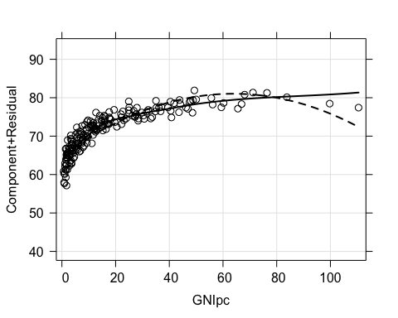

plot(Effect("LifExp", MRL.2, residuals=TRUE),   
 lines=list(col=c("black", "black"), lty=2),   
 axes=list(grid=TRUE), confint=FALSE,   
 partial.residuals=list(plot=TRUE, smooth.col="black", lty=1, span=3/4),   
 xlab="LifExp", ylab="Component+Residual", main="")

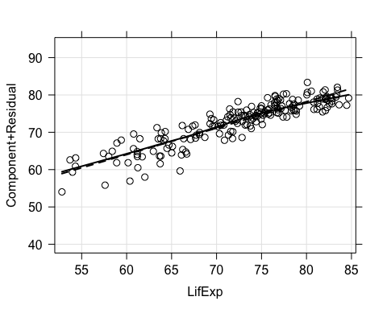

plot(Effect("Educ", MRL.2, residuals=TRUE),   
 lines=list(col=c("black", "black"), lty=2),   
 axes=list(grid=TRUE), confint=FALSE,   
 partial.residuals=list(plot=TRUE, smooth.col="black", lty=1, span=3/4),   
 xlab="Educ", ylab="Component+Residual", main="")

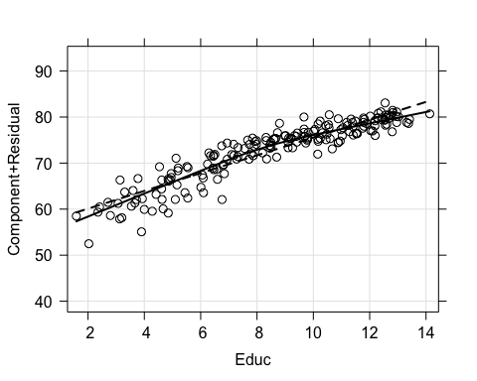

# Gráficos de modelos marginales  
mmps(MRL.2, sd=TRUE)

## Warning in mmps(MRL.2, sd = TRUE): Splines and/or polynomials replaced by a  
## fitted linear combination

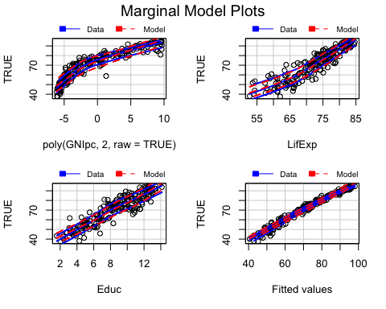

# MULTICOLINEALIDAD  
S(MRL.2)

## Call: lm(formula = HDI ~ poly(GNIpc, 2, raw = TRUE) + LifExp + Educ, data =  
## HDI_2018)  
##   
## Coefficients:  
## Estimate Std. Error t value Pr(>|t|)   
## (Intercept) -3.105983 2.658889 -1.168 0.244   
## poly(GNIpc, 2, raw = TRUE)1 0.505837 0.037365 13.538 <2e-16 ***  
## poly(GNIpc, 2, raw = TRUE)2 -0.003965 0.000386 -10.272 <2e-16 ***  
## LifExp 0.708359 0.043682 16.216 <2e-16 ***  
## Educ 1.932979 0.102801 18.803 <2e-16 ***  
## ---  
## Signif. codes: 0 '***' 0.001 '**' 0.01 '*' 0.05 '.' 0.1 ' ' 1  
##   
## Residual standard deviation: 2.529 on 184 degrees of freedom  
## Multiple R-squared: 0.9725  
## F-statistic: 1625 on 4 and 184 DF, p-value: < 2.2e-16   
## AIC BIC   
## 894.01 913.46

vif(MRL.2)

## GVIF Df GVIF^(1/(2*Df))  
## poly(GNIpc, 2, raw = TRUE) 3.104295 2 1.327366  
## LifExp 3.125909 1 1.768024  
## Educ 2.951140 1 1.717888